**Installing Theano, Tensorflow and Keras for Windows 10**

[Siraj](https://www.udemy.com/user/anonmcanonymous/) [· Lecture 221](https://www.udemy.com/machinelearning/learn/v4/t/lecture/6118392) · 9 months ago

Not a question as such, more intended to help other users.

I had a bit of trouble getting everything to work so I thought I'd outline what worked for me in the end (I used Windows 10, so the following is Windows specific, but can be adjusted for other operating systems).

I would recommend following the instructions in the course video first. If you're having trouble getting the packages to behave, this might be a useful alternative.

**Step 1 - Create New Conda Environment)**

Tensorflow didn't work with Python 3.6 for me, but I was able to get all packages working with 3.5.3. Luckily Anaconda has a really cool feature called 'environments' that allows more than version of Python to be installed in a different environments, each with different packages installed as you see fit. So you could have one environment for the sole purpose of these tutorials if you wanted, and it won't mess up your default Python install. This allows us to keep 3.6 as the default Python, whilst installing an older version, as well, for use with tensorflow.

To create the new environment called 'py35' open up the Windows command prompt and type:

conda create -n py35 python=3.5 anaconda

Call the environment whatever you want, I'm not the boss of you.

Note: This automatically installs python 3.5 in the new environment.

**Step 2 - Install Spyder in the New Environment)**

We can now start adding stuff to this environment. To do this, first activate the environment by typing the following into the command prompt:

activate py35

The command prompt should now change to have a (py35)  at the beginning of each line. This indicates that we're working in the new py35 environment.

We can't actually use the version of Spyder that is already installed with the default Python. Running this version of Spyder will automatically use the default version of Python.

So we need to install Spyder within the new environment:

conda install spyder

**Step 3 - Install the Packages)**

Once spyder has been installed we can install the relevant packages. Again we need to be in the relevant environment, so type:

activate py35

if needs be. Then type:

conda install theano

conda install tensorflow

conda install keras

Hopefully this should complete without errors.  
  
If you're having trouble getting tensorflow to work try:   
  
pip install --ignore-installed --upgrade https://storage.googleapis.com/tensorflow/windows/cpu/tensorflow-1.1.0-cp35-cp35m-win_amd64.whl   
as in the site:

https://www.tensorflow.org/install/install_windows

Also note that, when importing theano in Spyder, I got a message in the IPython console saying that I should install m2w64-toolchain to greatly improve performance. For me, this stopped theano from working and uninstalling m2w64-toolchain didn't fix the issue. I had to create a new environment and reinstall everything from scratch. Others may have better luck with m2w64-toolchain, but I had problems with it. I'd recommend cloning your environment and installing this on the cloned environment to test it first.

If you want the fancy GPU version of tensorflow, just type:

pip install --upgrade https://storage.googleapis.com/tensorflow/windows/gpu/tensorflow_gpu-0.12.1-cp35-cp35m-win_amd64.whl

as from the site:   
  
https://www.tensorflow.org/versions/r0.12/get_started/os_setup

I actually had trouble getting this GPU version of tensorflow to work, but this method matches what I've seen online. One tip I can give regarding the gpu version is that I had better luck when I used pip install  for all the above packages, rather than conda install . Things got a little complicated though, as to get the gpu version working I needed to install cuDNN from https://developer.nvidia.com and configure it correctly. So I just stuck with the cpu version for now.

**Step 4 - Run Spyder from the Environment)**

In order to make sure that we're using Spyder with the relevant version of Python (version 3.5.3, with the packages installed in the last step), type:

activate py35

if you're not already in the environment, and then type:

spyder

to launch Spyder using Python 3.5.

In the IPython console, you should see Python 3.5.3 in the top line.

**Step 5 - Test the Packages)**

As a cursory check that the packages are working, you can try running the following from within ann.py in Spyder:

1. import theano
2. import tensorflow
3. import keras

If the IPython console doesn't spit out any error messages you're probably good.

**Note 1)**

The downside of this method is that, everytime you want to use Spyder, in order to make sure it's working with the correct version of Python (3.5 rather than the default 3.6 installation) you would have to open up a command prompt and run:

activate py35

followed by:

spyder

to launch Spyder.

There's probably a way to get Spyder to link to the correct environment from within Spyder's user interface, but after tinkering about I decided the above method was easier.

I think being able to organise different Python installs into different environments more than makes up for having to do some stuff in the command prompt.  
  
**Note 2)**  
  
Because a new environment is created some of the packages will need installing:

activate py35

pip install matplotlib

pip install pandas

pip install sklearn

Best of Luck!

Siraj

Follow Responses

MB

[Maiia](https://www.udemy.com/user/maiia-bakhova/) — Teaching Assistant

 · 9 months ago

Thank you very much, McAnonymous! I think this will help a lot of students save their time.

Mya

[Mark as helpful](javascript:void(0))

SR

[Siraj](https://www.udemy.com/user/anonmcanonymous/)

 · 9 months ago

No problem at all, glad I could help!

[Mark as helpful (3)](javascript:void(0))

[Celine](https://www.udemy.com/user/celine-xu/)

 · 9 months ago

Thank you so much!

It works this time. a note-- I had some problem when I use in (py35) environment

   conda install tensorflow

   conda install keras

The system says package not exist, but I change the command to

  pip install tensorflow

  pip install keras

Then when I activate Spyder in this py35 environment and use

1. import theano
2. import tensorflow
3. import keras

   to test , I did not get any error reporting. So i suggest, it works so far!

Thank McAnonymous, A again!

Regards,

[Mark as helpful (6)](javascript:void(0))

SR

[Siraj](https://www.udemy.com/user/anonmcanonymous/)

 · 9 months ago

No problem Celine, I'm glad it worked for you!

[Mark as helpful](javascript:void(0))

OD

[Oleksandr](https://www.udemy.com/user/oleksandr-dolynskyi/)

 · 9 months ago

Thanks a lot!

[Mark as helpful (1)](javascript:void(0))

JG

[Jan](https://www.udemy.com/user/jan-giacomelli/)

 · 9 months ago

Thanks a lot

[Mark as helpful](javascript:void(0))

[Reggie](https://www.udemy.com/user/peter-humiston/)

 · 9 months ago

THANK YOU!!!!!!!!!!!!!!!!!!!!!!!!!!!!!!!!!!!!!!!!!!!!!!!!!!!!!!!!!!!!!!

[Mark as helpful](javascript:void(0))

HF

[Herberth Birck](https://www.udemy.com/user/herberth-birck-frohlich/)

 · 8 months ago

Thank you very much.

[Mark as helpful](javascript:void(0))

[Puchit](https://www.udemy.com/user/puchit-hongsawat/)

 · 8 months ago

Could anyone help me with the tensorflow    I have a problem with this package  TT ... but for the theano and keras,they work just fine   
  
here it looks like this

(py35) C:\Users\czech>pip install  
You must give at least one requirement to install (see "pip help install")

(py35) C:\Users\czech>pip install --ignore-installed --upgrade  
You must give at least one requirement to install (see "pip help install")

(py35) C:\Users\czech>pip install --upgrade  
You must give at least one requirement to install (see "pip help install")

[Mark as helpful](javascript:void(0))

[Puchit](https://www.udemy.com/user/puchit-hongsawat/)

 · 8 months ago

(C:\Users\czech\Anaconda3) C:\Users\czech>conda create -n py35 python=3.5 anaconda

CondaValueError: prefix already exists: C:\Users\czech\Anaconda3\envs\py35

(C:\Users\czech\Anaconda3) C:\Users\czech>activate py35

(py35) C:\Users\czech>conda install spyder  
Fetching package metadata .............  
Solving package specifications: .

# All requested packages already installed.  
# packages in environment at C:\Users\czech\Anaconda3\envs\py35:  
#  
spyder                    3.1.4                    py35_0

(py35) C:\Users\czech>activate py35

(py35) C:\Users\czech>conda install theano  
Fetching package metadata .............  
Solving package specifications: .

# All requested packages already installed.  
# packages in environment at C:\Users\czech\Anaconda3\envs\py35:  
#  
theano                    0.9.0                    py35_0

(py35) C:\Users\czech>conda install tensorflow  
Fetching package metadata .............

PackageNotFoundError: Package missing in current win-64 channels:  
  - tensorflow

^^^^^^^^^^^

everthing work just fine until the "install tensorflow" part

[Mark as helpful](javascript:void(0))

[Puchit](https://www.udemy.com/user/puchit-hongsawat/)

 · 8 months ago

so this time I've tried using anaconda prompt instead     
and here what I've got

(C:\Users\czech\Anaconda3) C:\Users\czech>activate py35

(py35) C:\Users\czech>conda install theano  
Fetching package metadata .............  
Solving package specifications: .

# All requested packages already installed.  
# packages in environment at C:\Users\czech\Anaconda3\envs\py35:  
#  
theano                    0.9.0                    py35_0

(py35) C:\Users\czech>conda install tensorflow  
Fetching package metadata .............

PackageNotFoundError: Package missing in current win-64 channels:  
  - tensorflow

(py35) C:\Users\czech>conda install keras  
Fetching package metadata .............

PackageNotFoundError: Package missing in current win-64 channels:  
  - keras

 T-T

[Mark as helpful](javascript:void(0))

[Puchit](https://www.udemy.com/user/puchit-hongsawat/)

 · 8 months ago

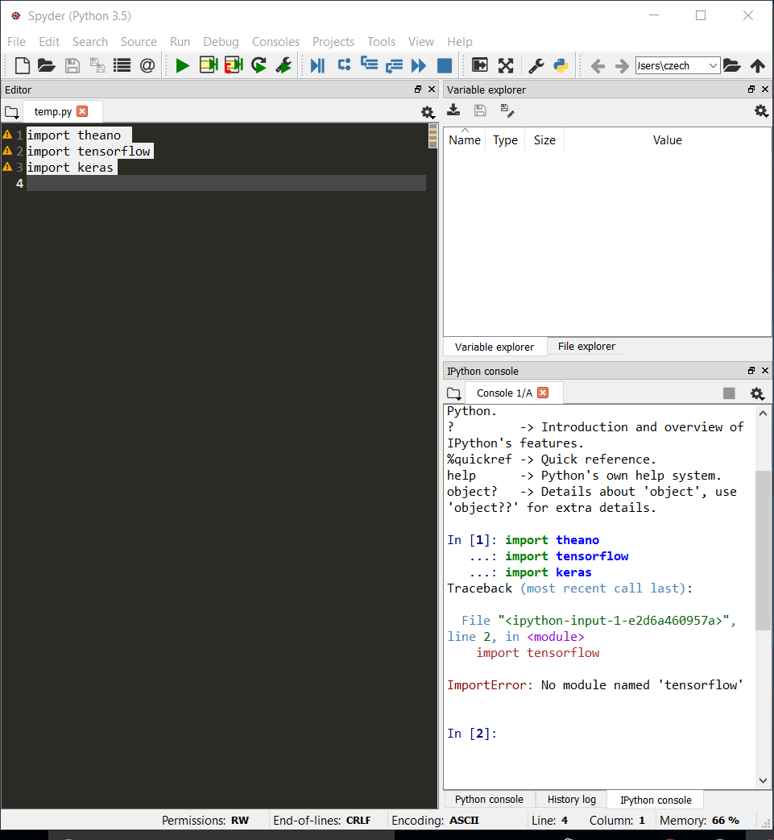

[Mark as helpful](javascript:void(0))